Final Project Deep Learning

Project Goal and Data Description The objective of this work is to build a model that predicts whether a given movie review is positive or negative. For this purpose, the models used "IMDB Movie Reviews Dataset," which consists of free-text reviews as a feature and label either 'positive' or 'negative'. Therefore, this is a classification problem. The data was split into an 80% training set and a 20% test set, maintaining a consistent random split across all constructed models.

Simplest Baseline
This model is an extremely basic classification model that completely ignores the content of the reviews and always predicts the majority class in the data (in this case, the quantities were equal, so it defaulted to predicting 'negative'). The results of this model help are a lower bound for comparison with more advanced models, as any advanced model is expected to outperform such a simple baseline.
Results:
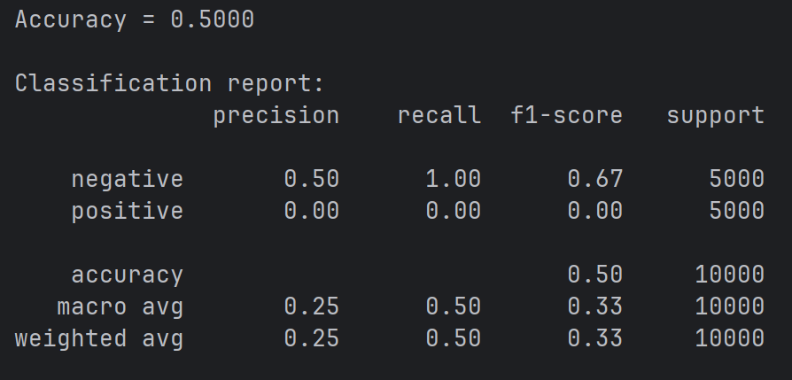

Rule-Based Classifier
We build model that have lists of good and bad words and the model we take each description first of all we transformed all the letter to a lowercase and removed all the chars that are not a-z or space and count how many good words and how many bad words there are and if there are more positive we will return positive and else we will return negative.
First Attempt:
Our lists:
positive_words = [
"good", "great", "best", "love", "liked",
"perfect", "well", "nice”, “positive"
]
negative_words = [
"negative", "bad", "worst", "boring", "awful", "waste",
"hard”, “hate"
]
Results:
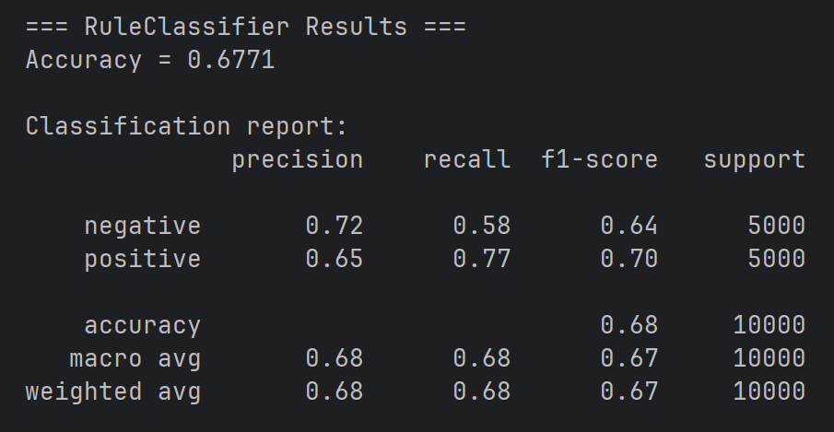as we can see there is an upgrade from the dummy model [we got above 0.5] but we still want to improve the model.

Second Attempt:
We tried to think about more positive and negative words.
Our lists:
positive_words = [
"good", "great", "best", "love", "liked",
"perfect", "well", "nice","positive"
, "wonderful", "excellent", "amazing", "enjoyed"
]
negative_words = [
"negative", "bad", "worst", "boring", "awful", "waste",
"hard","hate",
"pointless", "terrible", "annoying", "poor", "disappointing"
]
results:
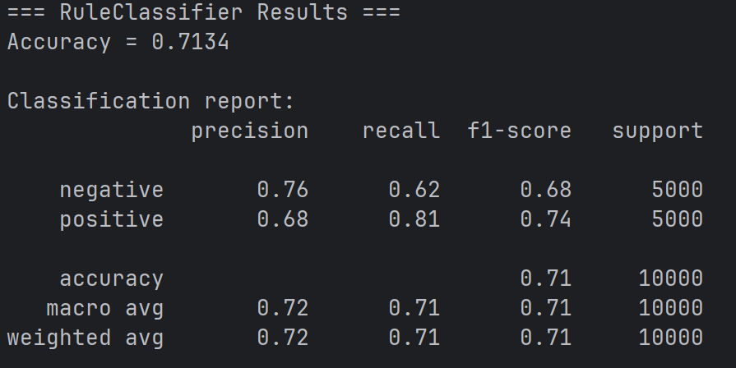
We can see that there is improvement of 0.3363 but still we think about another upgrade to our lists.

Third and Final Attempt:
In our third attempt we tried to remove the inconclusive words from the lists ( e.g good because we can also say not good and its common phrase that people may write but with the opposite meaning)
positive_words = [
"great", "best", "love", "liked",
"perfect", "well","positive"
, "wonderful", "excellent", "amazing", "enjoyed"
]
negative_words = [
"bad","negative","worst", "boring", "awful", "waste",
"pointless", "terrible", "annoying", "poor", "disappointing"
]
results:
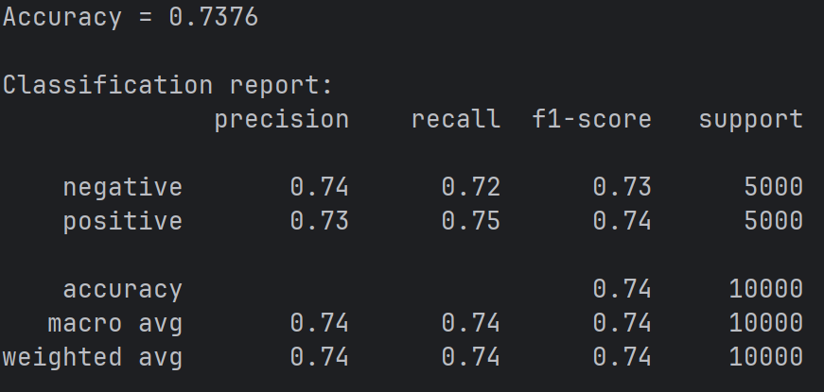
We can see there is small improvement of 0.0242

Logistic Regression:
The model uses the content of the review (free text) as a feature.
Since the model cannot work directly with text, we converted the reviews into a numerical representation using the Bag-of-Words method (as learned in the lecture).
We built a Vocabulary using only the training set. To save memory, we limited the vocabulary to the top 20,000 most frequent words. Each review is represented as a numerical vector. Each number in the vector shows how many times a specific word from the vocabulary appears.
The model tries to predict the label of the review. To use Logistic Regression, we converted the "positive" label to 1 and the "negative" label to 0. The model predicts a number between 0 and 1, which is then converted to the final label. We implemented this Logistic Regression model using PyTorch.
First attempt:
We use learning rate 0.001, number of epochs = 2000
Results:
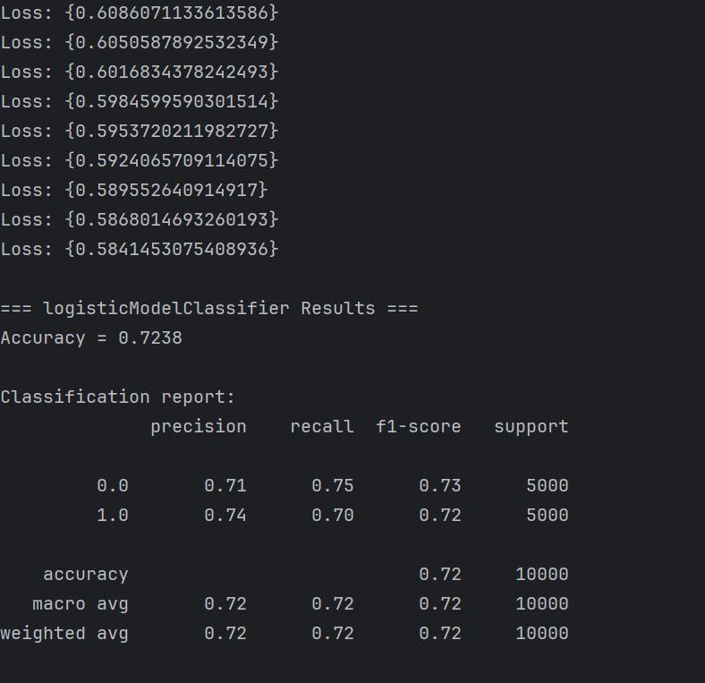
We can see that this model with those parameters isn’t better from the best result we got in the rule-model so we have a lot more to improve.
Second Attempt:
At this point we taught that we didn’t had enough epochs for the training so we increased the number of Epochs.
So know we used learning rate = 0.001 and number of epochs = 20000
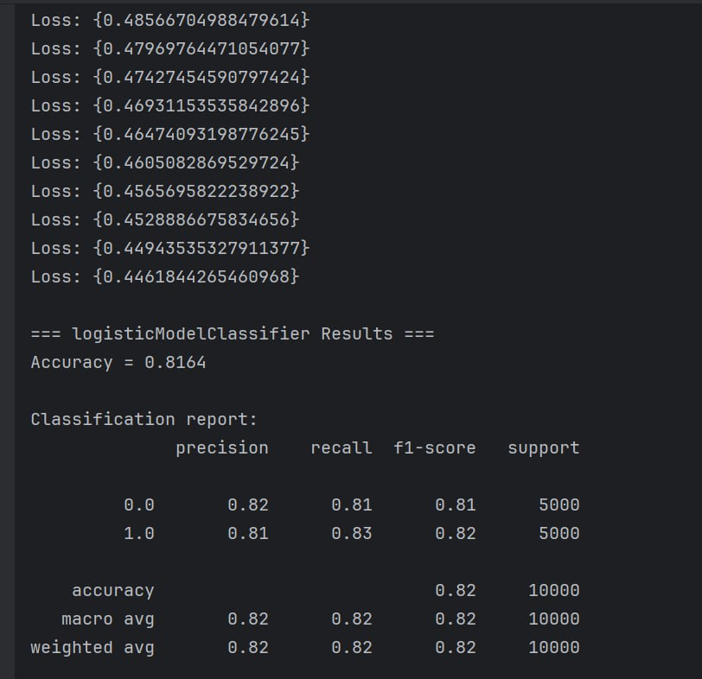
Know we can see a huge upgrade in the accuracy of 0.0926 (9.26%)
But we still believe that the logistic regression model can get better results.

Third Attempt:
This time we tried to change the loss function in order to upgrade the accuracy of the prediction we tried to use MSE loss function instead of BCE
we used learning rate = 0.001 and number of epochs = 20000
x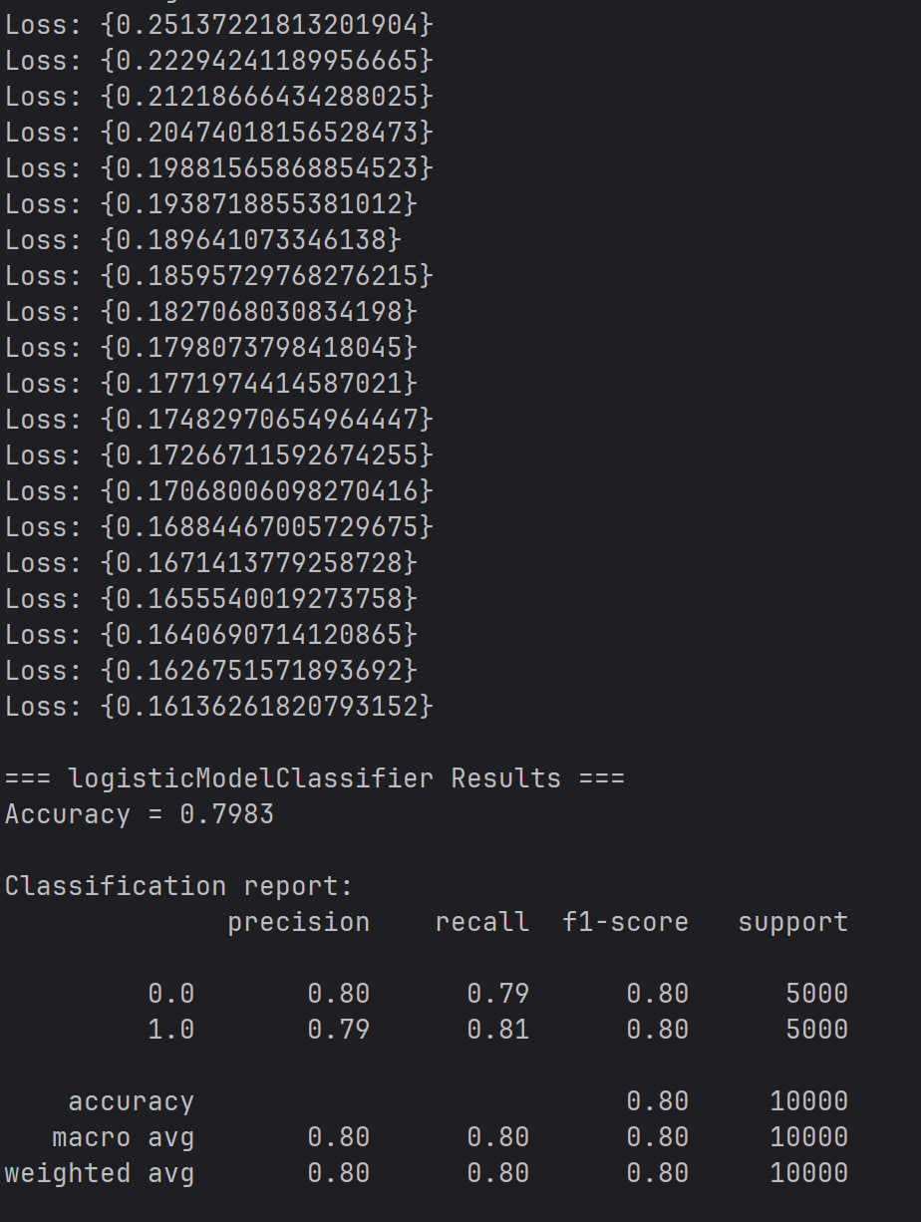
The results are poor than the results we achieved before so we decided to stay with the BCE

Four and Last Attempt:
This time we tried to increase the number of Epochs once again:
we used learning rate = 0.001 and number of epochs = 30000
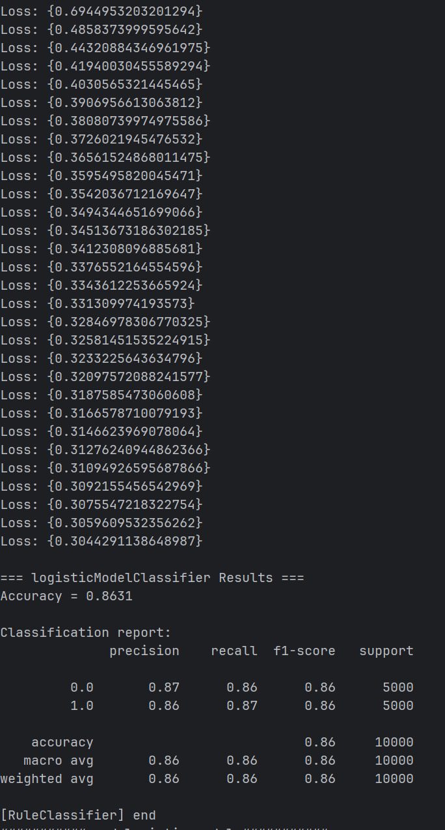
We can see that this model shows a great improvement of 0.0467 this is our best and final result

Comparison to base-line:
 | Dummy | Rule- based | Logistic regression
ACC | 50.00% | 73.76% | 86.31%
Negative precision | 50% | 74% | 87%
Negative recall | 100% | 72% | 86%
Negative F1-score | 67% | 73% | 86%
Positive precision | 0% | 73% | 86%
Positive recall | 0% | 75% | 87%
Positive F1-score | 0% | 74% | 86%

Fully Connected Neural Network:
In the last part, we used a fully connected neural network for classification. The network has two hidden layers with ReLU activation functions. The input to the network is the same numerical representation of the reviews that was used before (Bag-of-Words with a limited vocabulary). The model was trained using Binary Cross Entropy (BCE) loss. the output of the model was converted to a binary prediction using a threshold of 0.5.
First attempt:
We used MLP with input Dim= 20000, output Dim=1 and one hidden layer of 128 neurons with and SGD as our optimizer
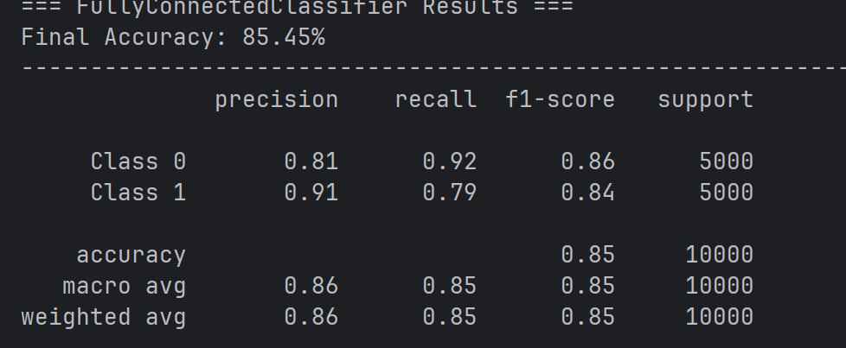

Last model:
To upgrade our model we changed the optimizer to Adam (dividing the dataset to mini batches and update the weights and learning rate) instead of SGD
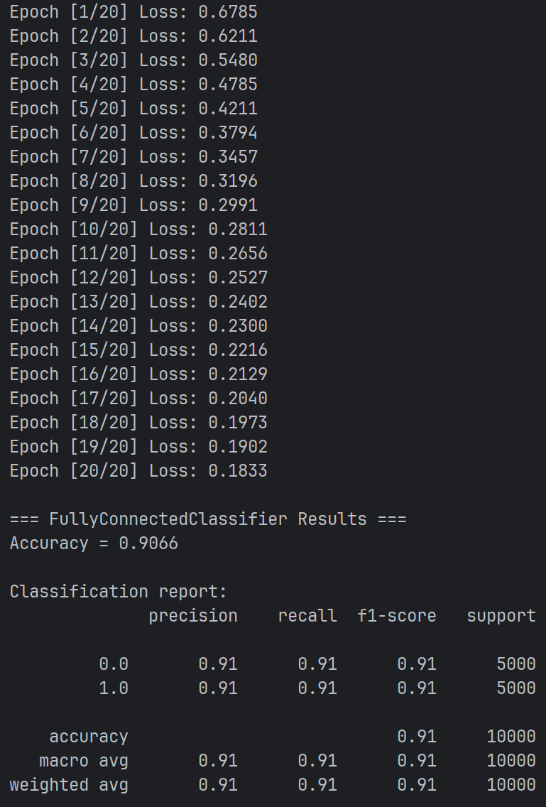

Final Comparison:
 | Dummy | Rule- based | Logistic regression | Fully connected Neural Network
ACC | 50.00% | 73.76% | 86.31% | 90.66%
Negative precision | 50% | 74% | 87% | 91%
Negative recall | 100% | 72% | 86% | 91%
Negative F1-score | 67% | 73% | 86% | 91%
Positive precision | 0% | 73% | 86% | 91%
Positive recall | 0% | 75% | 87% | 91%
Positive F1-score | 0% | 74% | 86% | 91%

We can see an upgrade between each 2 models in every aspect except the fact that the Dummy has the best Negative recall but it is because he always predicts negative.

